Term: tag visualization

# Research Question *ideas*:

1. What is the influential network path of one’s tweets towards his/her followers into retweet it?
   1. Vertices = one’s tweets
   2. Edges = retweets
2. What keywords are trending a county’s search engine, such as Google?
   1. Vertices = Words/phrases
   2. Edges = Frequency of usage
3. Which countries are more friendly towards friend networks from other countries on social media platforms?
4. Vertices = Countries
5. Edges = Number of friends from a specific country

# Research Question Youtube idea:

1. How Youtube channels give the recomandation of one’s favourite channels?
2. Vertices = Channels
3. Edges =

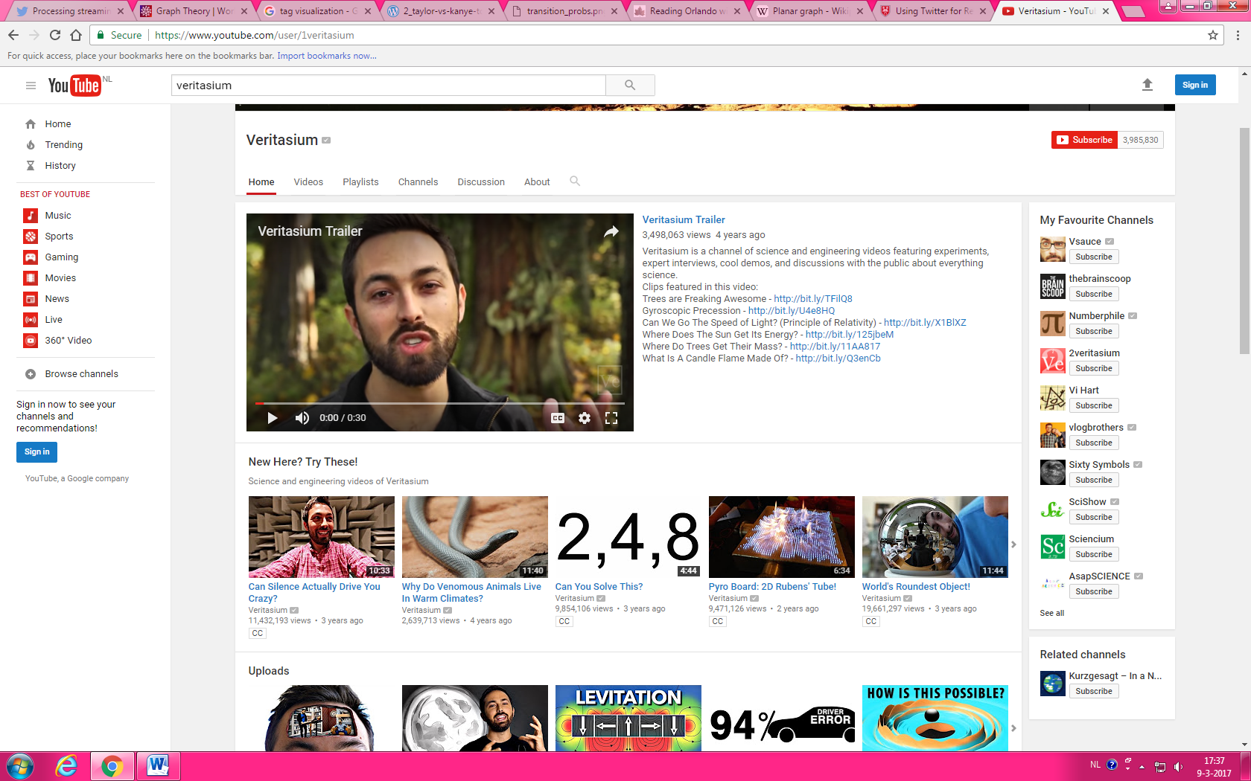

Youtube graph:

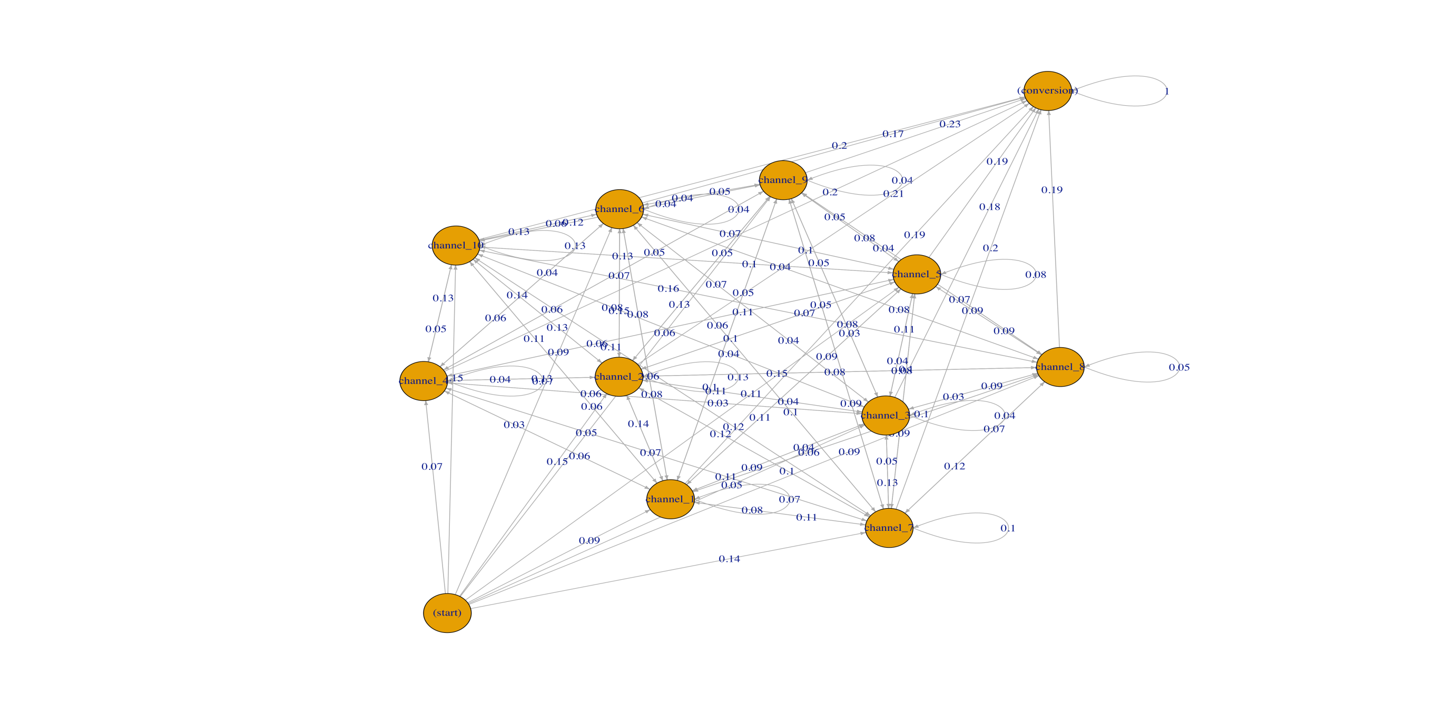

# Research Question Tweeter emoji idea:

1. What emojis are mostly used by people to express their emotional feelings when making a social post?
2. Vertices = emoji
3. 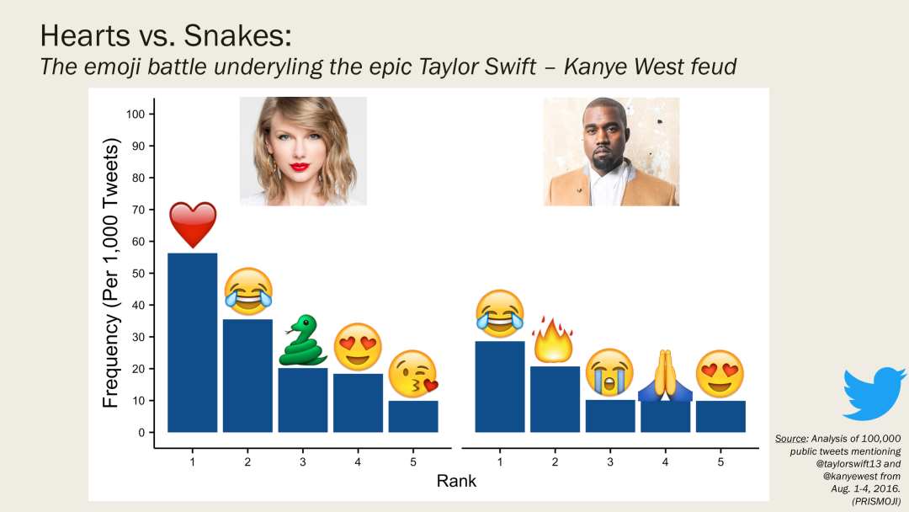Edges = Frequency of usage

Topic: immigration and emigration in the USA

Main question:

How will the immigration/emigration ratios between the USA and middle-eastern countries affect citizen racial demographics?

# Sub-research question:

1. What are the immigration and emmigration rates of the USA to and from each middle-eastern country?
2. What are the current racial demographics in the USA and middle-eastern countries?

* edges-have direction indicating where peoples choose to immigrate/emigrate
* vertices – countrie

Topic: Improving Pokémon type chart

# Research Question:

How can the Pokémon type chart be improved based on general internet consensus?

# Sub-research questions:

How should general internet consensus be established?

What are the attributes of an ideal type chart?

How can various type charts be efficiently generated and analysed?

Topic: followers recommendation idea

# Research Question:

How does Facebook/twitter/YouTube etc. recommend things to us?

use graph theory to see if a node in whatever case has an arbitrary amoint of edges to another node

node could be videos/friends/followers

Graph is tool,question is the relation

Topic: Determining political opinion based on social media posts and friend networks.

# Research Question:

To what extent can an individual’s political opinion be determined based on social media friend networks and social media posts?

# Sub-research questions:

What social media platform is most suitable for determining political opinion and analysis?

What in a person’s social media posts can be used to infer that person’s political opinion?

What in a person’s social media friend network can be used to infer that person’s political opinion?

What type of algorithm can be used to efficiently determine a person’s political opinion based on social media posts and friend network?

How can the chosen algorithm best be implemented?